John Lycett’s blog – October 2025
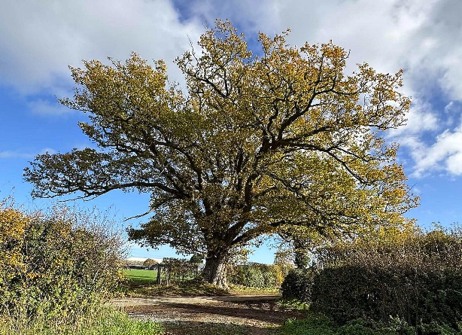
A couple of weeks ago I was on the yard at Wykey and happened to bump into Mark, Steven and George. The discussion soon got onto the harvest and autumn drilling. Mark said “It’s been continual since 1st July - combining grain, grass silaging, lucerne harvesting, spraying and cultivations. Then came the maize harvest and drilling winter hybrid rye, rape and wheat”. They all said it had been non-stop. Since then, they have lifted some energy beet and carried on drilling. We all agreed it had been an exceptional autumn.

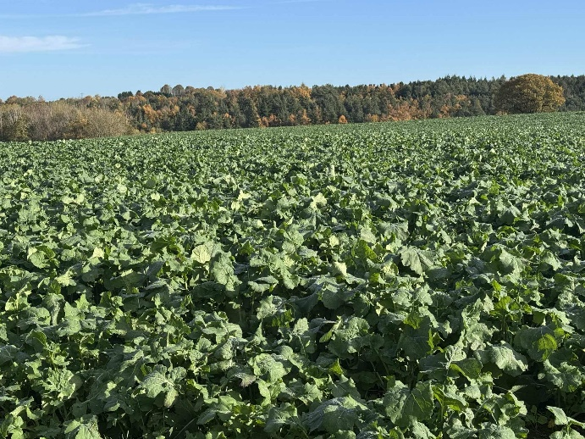
It's now time to take a breath and look about. The colours of the trees and hedgerows, the abundance of berries and the emerging autumn crops are signs of how quickly time passes.

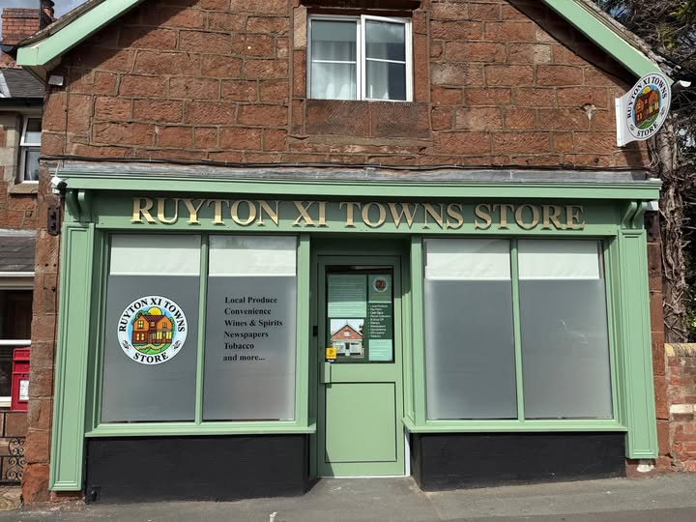

After a long time without our village shop, it has now reopened. Tim, the new owner, has a very well stocked shop and is very keen to promote and sell local produce. Up to now, I notice, he has local vegetables, eggs, honey, bread, meat and cheeses.
I wish him and his family every success with this venture.
The farm has had a new tractor on demonstration. It’s a different colour than the rest but I asked Mark Pitcher what he thought. He observed “It’s got a spaceship cab (a bit small) with more screens, dials and buttons than I can get my head round but it is very quiet”. If this joins the current fleet, it will certainly be seen coming through the village.
Commodity prices – Wheat jumped £3.40/t, but twenty-four hours later it was back down again. It is very difficult at the moment. Consider my friend who is a dairy farmer who milked his cows in the evening for 40pence/litre and the next day he milked his cows for 34p/litre. He had the same work load, feed bill, electricity, insurances, wages etc. Enough of a fright for hallowe’en! Long term planning is vital as farmers work on lengthy cycles and the lack of certainty is a killer.
The price of potatoes is on the floor but my local fish and chip man has still increased his prices because of his continually rising overheads.
Christmas is coming so hopefully will bring some cheer!

